RETFORD ATHLETIC & RUNNING CLUB RETFORD HALF MARATHON AND FAMILY FUN RUN SUNDAY 10th MARCH 2024
Start/Finish at
RETFORD OAKS ACADEMY, BABWORTH ROAD, RETFORD (Post Code DN22 7NJ)
UKA Race Licence Number 2024-47022 (Run under UKA rules)

RUNNER RACE DAY INSTRUCTIONS
Thank you for entering and supporting this event.
EVENTS: | THE HALF MARATHON | Run over an accurately measured one lap course, which is generally flat with slight inclines on surfaced roads and footpaths. On course mile markers will be positioned at, or as close as practical to the mile position and are a guide only. A map of the course route is included below.  (note that runners do not have priority over other members of the public using public footpaths or roads where these have not been closed for the event)
 | THE FUN RUN | Starting and finishing on the drive way of Retford Oaks but mainly run on grass on the Retford Oaks School playing field. (Please see map below and information regarding potential re-route below the map)
START: | THE HALF MARATHON  FUN RUN | On the school drive at Retford Oaks Academy. Please note that the race starts in the direction facing St Giles school and all runners are required to loop around the roundabout outside St Giles before leaving the school grounds. Please allow yourself plenty of time to arrive at the Half Marathon start point for the 10.00am start.  The Fun Run starts at 10.15am at the same point as the Half Marathon start.
RACE NUMBERS: |  | The numbers for the half marathon will be collected on the day from the race number collection point at Retford Oaks.

Please present to our queries desk at Retford Oaks if you have any queries on race day. This will be located in the cafeteria at Retford Oaks and will be open from 08.15am - 09.30am.

Note that we are able to provide replacement numbers for lost or forgotten numbers, however a £5 charge will be made for these and proof of identify will be required.

Fun Run Race Number collection
All Fun Run numbers will be collected on the day from the Fun Run desk in the Retford Oaks Canteen.
FINISH: | HM & FR | Adjacent to the sports hall at Retford Oaks.
CAR PARKING: | Limited car parking will be available at Retford Oaks Academy.  Car, coach and minibus parking is also available at various public car parks across Retford. All of these are within 10-20 mins (approx.) walk from Retford Oaks Academy. Please note that parking charges may apply. The enclosed map shows the public car parks in Retford. Please note that car parking  IS NOT available at Retford Leisure Centre.  There is no longer any parking available at Retford Tennis Club.  Please DO NOT park on roads adjacent to Retford Oaks, or at any point on Hospital/Babworth Road. (Note that some entrants did park on adjacent roads including West Carr Road at a previous event despite our request not to, which did generate complaints from local residents!). Please help us to avoid this this year!  Take care when leaving the Retford Oaks Academy as other runners may still be finishing.

During the fun run and Half Marathon vehicles will only be permitted to leave the school site using the marked out route and under escort from our car park marshals.
We would encourage local runners to run / walk / cycle to the venue.
TOILETS: | Portaloo’s are provided on site at Retford Oaks.
CHANGING & SHOWER FACILITIES: | Unfortunately we are unable to offer any changing or shower facilities this year. Please do not use the canteen area to change.
BAG STORAGE: | Limited bag storage is available in the canteen at Retford Oaks. Where possible please make your own arrangements to store baggage. Please do not leave valuables as Retford AC or the venue cannot accept liability for anything going missing.
DRINKS: | Available at approx. 4.5, 6.5, 9, 11 miles and Finish.
ENTRIES: | Online entry for the Half Marathon and Fun Run closed on Sunday 3rd March.  PLEASE NOTE THAT WE DO HAVE SOME ‘ON THE DAY’ ENTRIES AVAILABLE FOR THE 2024 RETFORD HALF  MARATHON - entries will be available on the day on a first come first served basis. The ‘on the day’ entry desk will open from 08.00am and close promptly at 09.30am.  On the day entry for the Half Marathon is priced at £28.00 (UKA Affiliated runners) and £30.00 (non-UKA Affiliated runners). Please have the correct change as we may not have change available.  On the day entry for the Fun Run is priced at £3.00. Please have the correct change as we may not have change available.  Please note we are unable to transfer, refund or defer places at this late stage.
TROPHIES & PRIZES –  Retford Half Marathon | Presentation of trophies / prizes will commence in the sports hall at approx. 12.30pm, but please be patient should there be any delay, as it takes time to compile the results.
Sponsors | We are grateful to all our sponsors including Tuxford Medical Centre, Jones & Co. BP Drinks,Retford Lions, Koko+Kind, North Nottinghamshire Physiopherapy, RWB Massage Therapist, Morrisons and our retail sponsor the Lincolnshire Runner who will be in attendance with its stall with offers on shoes and clothing plus a selection of nutrition.  If anyone would like something specific bringing from the shop please ring 01522 523326 before 5pm Saturday.
Retford Half Marathon Awards
Trophies will be awarded to the 1st, 2nd and 3rd Male and Female runners to complete the course and to the winners of the Male Veteran Categories (U/20, O/40, O/50, O/60, O/70,).

The winners of the Female Veteran Categories (U/20, O/35, O/45, O/55, O/65. A trophy will be awarded for the team corporate challenge for the first 3 runners from the same company that finish.
Spot prizes for 100th & 200th male and female finishers.
Please note that no competitor will be awarded more than one trophy / prize. Should a veteran finish 1st, 2nd or 3rd overall, then the major trophy and prize will be awarded to that person and the veteran prize awarded to the next person home in that category.
MEMENTO (HALF MARATHON) | A medal, 750ml water bottle and drawstring bag will be presented to all entrants with a valid race number who finished the Half Marathon AND entered online.  Please note that we are unable to guarantee finisher mementos for runners who entered on the day. Runners entering on the day will need to wait until all pre-registered runners have finished the half marathon before we are able to issue any of the items that are left. If you entered on the day and you do not receive finisher mementos we will refund £2 from your entry fee.
MEDALS (FUN RUN) | Medals will be presented to all who finish the fun run. Trophies and prizes for 1st, 2nd and 3rd place female and male finishers under 16.
FIRST AID | St Johns Ambulance personnel will be on duty throughout the event.
USE OF RETFORD OAKS ACADEMY | This is the eighth year we have used Retford Oaks Academy for the Retford Half Marathon. We have been given permission to use the great facilities at Retford Oaks by Kajima. In order to use the facility for future events it is essential that the building and grounds are left in an excellent condition ready for use by the school on Monday morning. To help with this, please use the bins provided to dispose of any rubbish or take this home with you. If you see any problems or witness anyone acting suspiciously in or around the school please alert the police, a marshal, or any other members of the event staff as soon as you can. The Retford Oaks buildings and site (including  playing fields) are strictly no smoking – please ensure your supporters are also aware of this.
EVENT SAFETY -  General | - Please use the football pitches/tennis courts at Retford Oaks to warm up. Please DO NOT use the road outside school.  - Runners should take care at all times to minimize any risk to the safety of themselves, other runners, and other members of the public including cyclists and drivers.  - Bright coloured/high visibility clothing is recommended for all.

- We do have a number of blind/partially sighted runners. Please take particular care to give these runners space, especially at points on the course which are not closed.
- In line with UKA rules and safety concerns only bone conducting headphones are allowed at this event, no noise cancelling/in ear headphones are permitted and the usage of this equipment may result in disqualification.
- Competitors must complete all fields on the reverse of their race numbers, and must not cut, fold or mutilate them. Please complete the fields on your race number before you arrive at the event.
- The course uses public roads and some A class roads. Please keep to footpaths where possible and take extreme care and caution when running on parts of the course that are not closed to road vehicles. Road vehicles have right of way on roads and at junctions that are not closed off. Runners must give way to cars on any part of the course where it is not safe for runners and cars to pass together. Take particular care:
a.) Leaving Retford Oaks heading up to Hallcroft Roundabout. The road is closed heading up to the Roundabout but is open to traffic heading in the opposite direction. Runners are permitted to run either on the pavement or on the road (in the direction of Hallcroft Roundabout), however please ensure you stay within the cones as you progress up Hallcroft Road to the roundabout.
- At the pinch point on the pavement leading from Babworth Road onto the Great North Road where pedestrians may be coming in the opposite direction. As traffic will be held on the Roundabout temporarily, runners are encouraged to take this corner on the road and NOT on the pavement.
- Once progressed onto the Great North Road, runners are encouraged to remain on the road but can also use the footpath. The road is closed in the direction of Ranskill/Doncaster (right through to Billy Button Lane at Torworth) but as traffic will be flowing on the opposite side of the road (towards Retford), please ensure that you stay within the cones. Please also adhere to the marshal instructions and course signage, and please be aware of traffic that will be turning out of (or into) homes/businesses/properties along Great North Road.
d.) At all points on the A634 (the Blyth to Barnby Moor road). This road is closed to main traffic but runners should take care when turning off Billy Button Lane onto the A634 and on all other parts of this road in case any vehicles make it onto this road during the race. Runners should remain on the right hand side of the road heading towards Blyth and the right hand side heading towards Barnby Moor after the turn around point.
d.) On Old London Road - runners should take care when

approaching the A1 slip road junction where it meets Old London Road. By this point runners should be on the left hand side of the road and should continue on the left hand side all the way to the top where Old London Road meets Babworth Road (as Old London Road will be open both ways to local residential traffic, and traffic coming from the A1 slip road junction).
e.) Runners should move onto (and remain on) the path on the left hand side of the A620 (the Worksop – Retford road) all the way to the school. The route no longer involves Ordsall Park Road therefore runners should stay on the left side of the A620 all the way back to Retford Oaks. Runners who do not remain on the pathway and/or do not adhere to marshal instructions may be disqualified as this is a busy and fast stretch of road and running on the road risks the safety of runners and other members of the public including cyclists and drivers.
- At all times runners must obey any direction given to them by police, marshals, or other race officials and adhere to the guidance above. Failure to comply will result in disqualification, possible legal proceeding, and also jeopardises the staging of this event in future years.
- We hope you enjoy the race, have fun and arrive safely at the Finish. Do take care at all times.
COVID GUIDANCE | EVENT VILLAGE  - All marshals and staff within the event and around the course will be issued with a high visibility vest to denote who they are.  - Race packs will be posted out ahead of the event.  - Please limit the number of belongings you bring to the event and if possible leave anything in a car. This is in order to reduce contact between runners and staff.  - You will see clear signage around the event village, please follow all signage and instructions from the marshals before, during and after the race.  - St Johns Ambulance medical support will be available at the finish area.  DURING THE RACE  - The race will not start in waves but we would ask that faster runners start nearer the front and slower runners nearer the back to avoid any congestion and the need to overtake on course.  - There will be water stations on the course (cups) and a water station at the end (sealed bottles) however we ask that you stay hydrated before the event and if you are able to please bring your own. Bottles and camelbacks are

permitted but please do not leave any bottles etc on the course – please take these home with you.
- If you need to overtake on the course please give a wide berth, if possible of at least 1 meter around any runners or members of the public (but do ensure you do not put yourself or any other runners or road users in danger)
- Spitting and nasal clearance during the race is not permitted.

AFTER THE RACE
- Do not stop within the finish barriers. Please continue past the finish until you collect and pass the finishers mementos and are in an open space.
10. We ask that once you have collected your finishers mementos and water and keep clear of the finishing line.

ROUTE MAP – RETFORD HALF MARATHON 2024
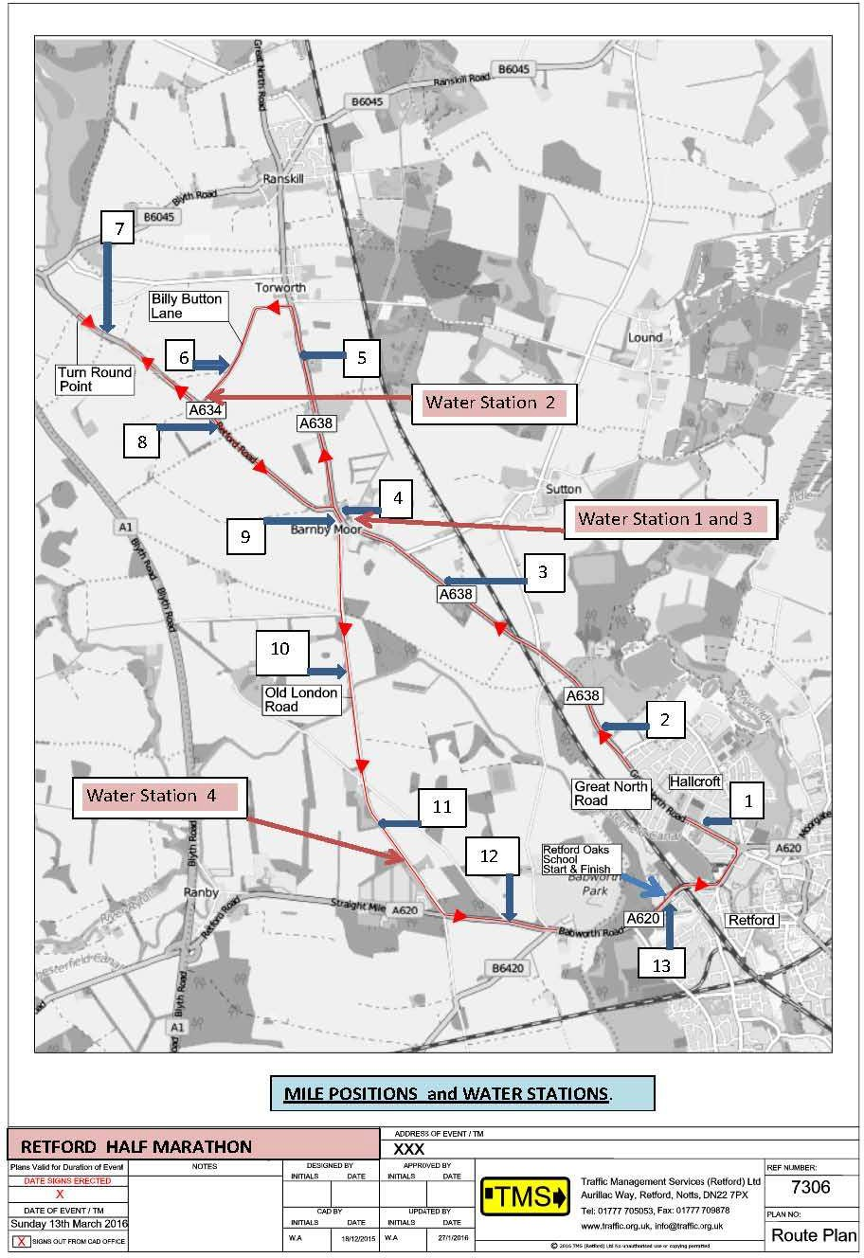

START / FINISH AREA LAYOUT – RETFORD HALF MARATHON & FUN RUN
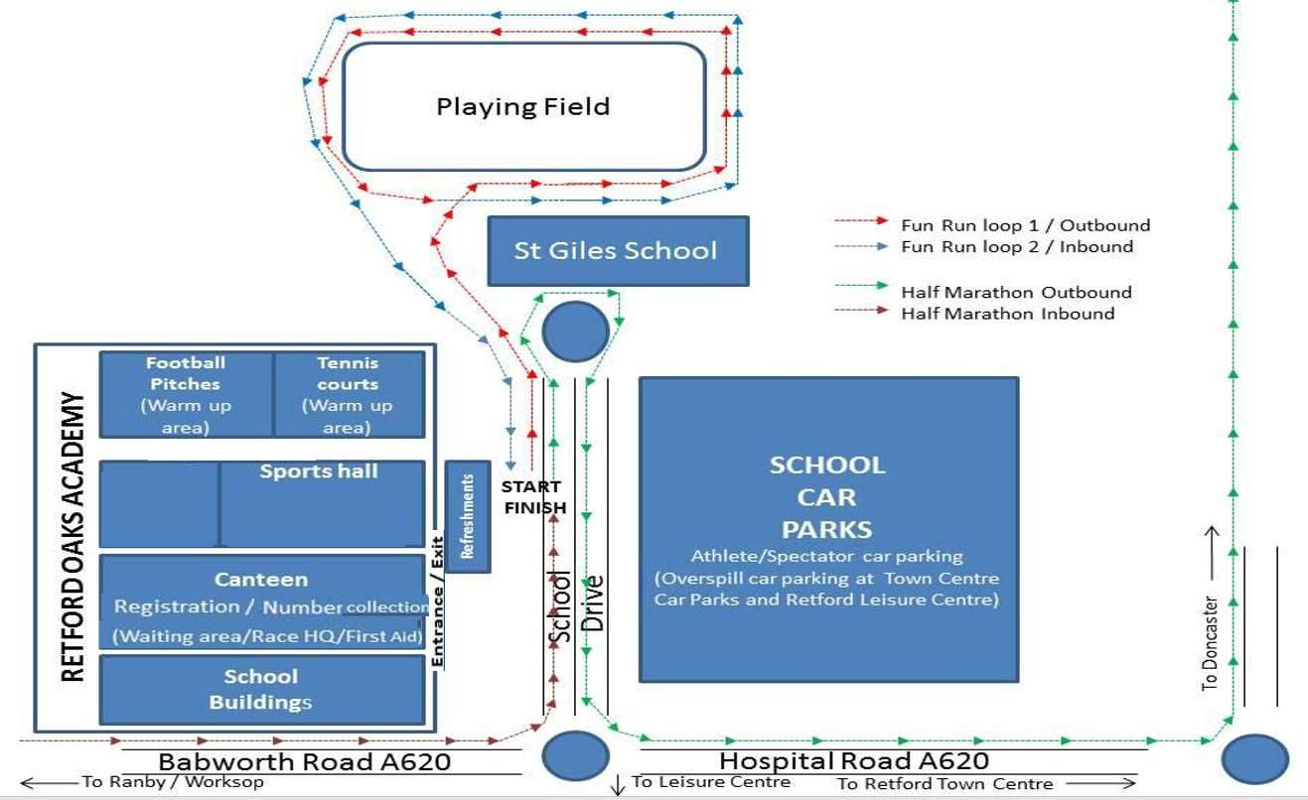

Please note that the fun run course is subject to change in the event the school field is flooded and becomes unavailable. In this circumstance we may re-route the fun run using the car park area – should we be required to do this, no vehicle movement will be permitted during the course of the fun run.

HALF MARATHON START – RETFORD HALF MARATHON 2024
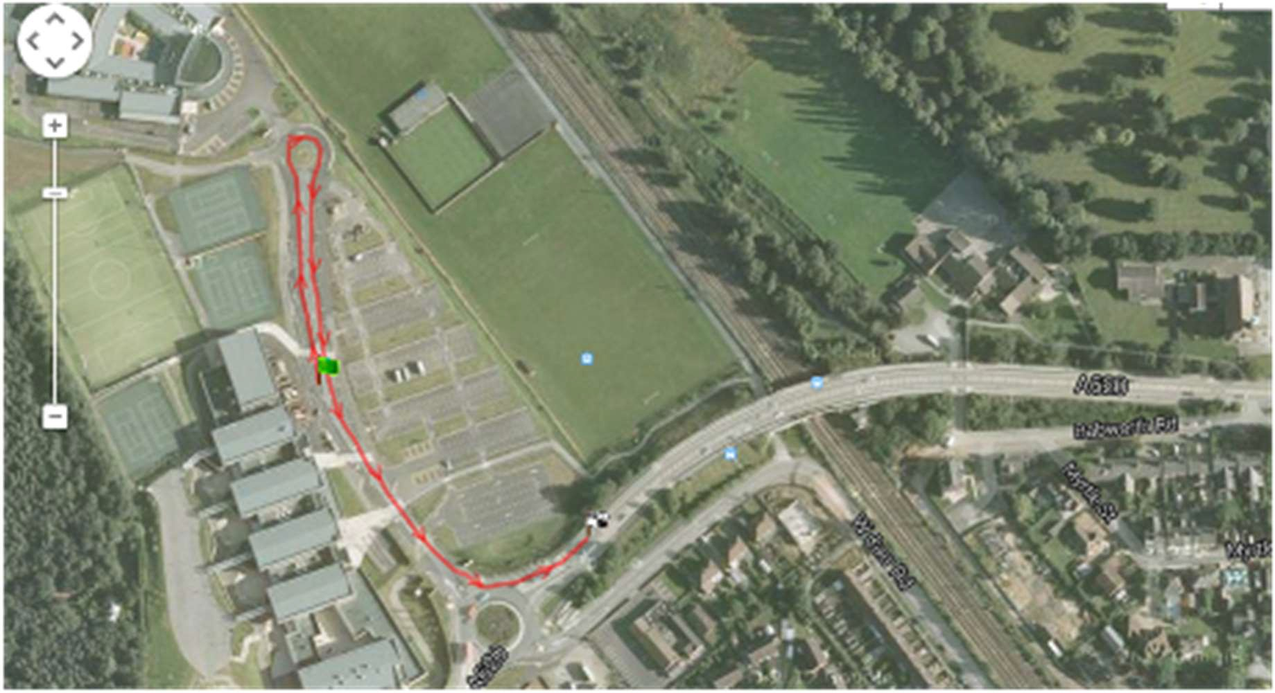

HALF MARATHON FINISH – RETFORD HALF MARATHON 2024
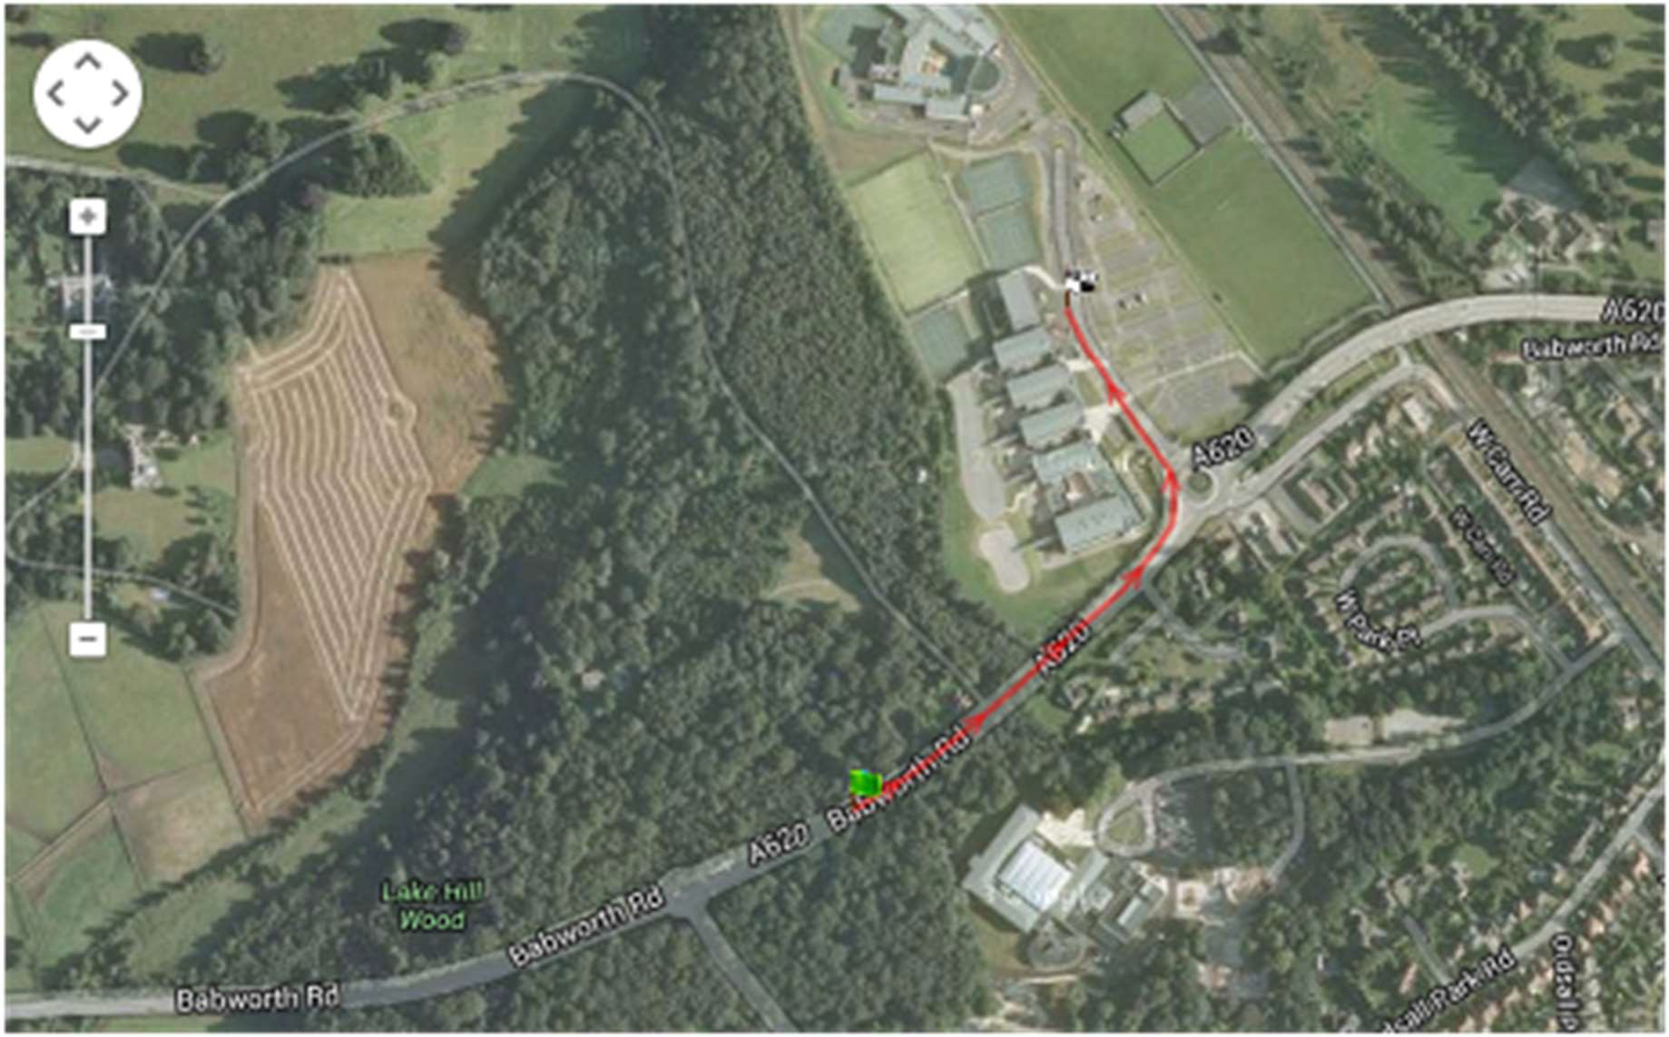

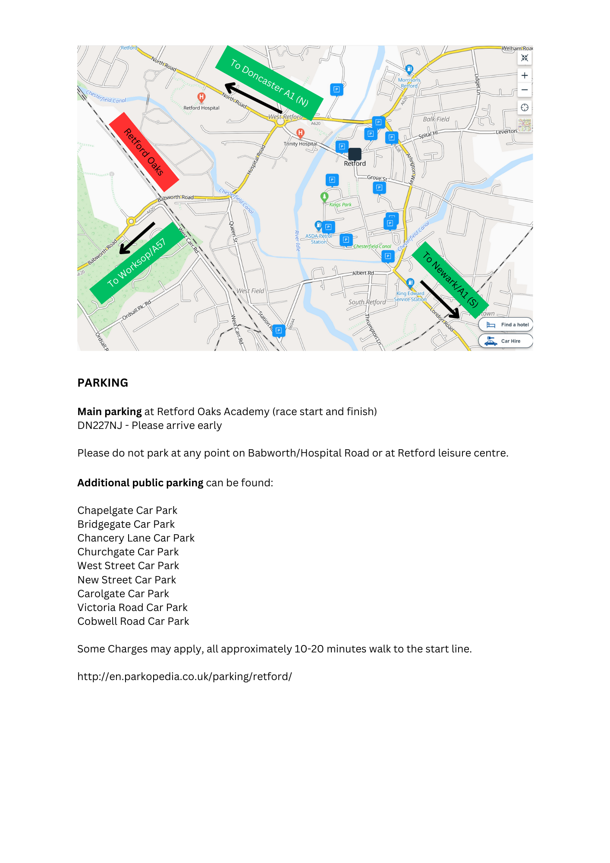
CAR PARK MAP – RETFORD HALF MARATHON 2024

http://en.parkopedia.co.uk/parking/retford/

